Twitter

1. Logon to twitter.com in your web browser. You’ll see two buttons – Sign Up and Log In. Click on the Sign Up button.



1. A form appears for you to fill up. Fill the form by entering your full name and your email address or your phone number, whichever you prefer and click on Sign up for Twitter to go to the next step of the process.
2. At the next step, Twitter asks you to recheck the information you previously entered and also suggests a username that is similar to your name. You could use the suggested username or create your own username. Enter the password you’ll be using for the account.

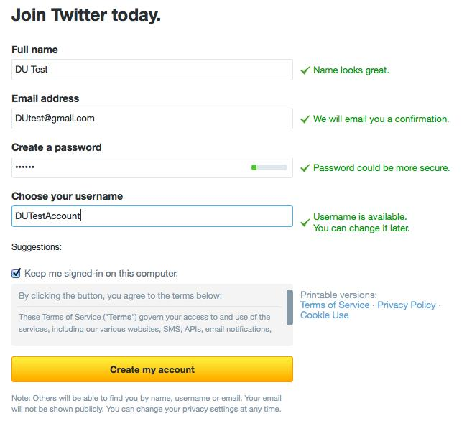

1. If all the entered information is within the parameters set by Twitter, you’ll see a green tick symbol at the end of each form field. Click on Create My Account button at the end of the form to proceed to the next step. You now have successfully created your Twitter account.
2. Twitter will now take you through a short tutorial, which includes suggestions of who to follow based on your email contacts and other popular accoun**ts.**



1. You will receive an email from Twitter asking you to click a link to validate your account. It's important to do this as soon as possible, as you may not be able to use all the features until you are validated.
2. If you know of a Twitter user by name that you would like to follow – a person, company or other organization, such as Microsoft – enter that name into the search box and click Search. You’ll receive a list of possibilities, including people and tweets containing your search terms.